Lab 5.1 Express

Instructions

1. Answer the below question in the boxes if needed.
2. Code on your computer and zip all your code before submission.
3. Please submit the assignment after you finish.

Part 1 Assignment

Q1 Which of these is an example of an API

a) A restful api hosted at https://foo.bar/api/v1

b) An OS framework exposing bindings to a language

c) Interface for interacting with an app

d) All of the above

[correct answer: ]

Q2. Can a router sometimes contain business logic?

a) No

b) Yes

[correct answer: ]

Q3. Which of these is the correct lifecycle of a request->response

a) Controller -> Router -> Middleware -> Interceptor

b) Router -> Controller -> Middleware -> Interceptor

c) Router -> Middleware -> Controller -> Interceptor

d) Interceptor -> Router -> Middleware -> Controller

[correct answer: ]

Part 2 Programming Task

Q1. Create an express app with the following routes

a) “/api/:animal/” where “animal” is a path parameter, when the route is visited the api should send back a response saying “ is the best!”. For example, visiting “/api/dog” shall return back “dog is the best!”

b) “/api/exponent/:n/:m” where “n” and “m” are path parameters, the api shall send back in response n^m, for example “/api/exponent/10/2” should return 100

Part 3 Programming Task

Q1. Create an Express API for Products, containing a basic array for products and perform

CRUD operations on them with the following routes.

Where a product would have 3 fields, “id”, “name” and “price”

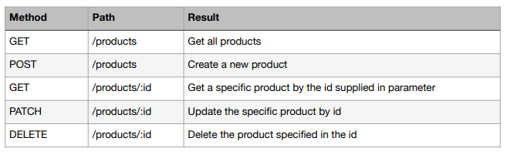

Q2. Create an Express App which has one route “/pyramid/:n” which creates a pyramid with

“n” rows, for example visiting “/pyramid/5” will render   
